|  |
| --- |
| **ASHENGROUND COMMUNITY CENTRE** |

Southdown Close,

Haywards Heath,

RH16 4JR

**12TH ISSUE – Winter 2017**

**NEWSLETTER**

The Community Centre belongs to us all, is run by local people and is here to be used by all sections of our community. The inside of this newsletter lists all the current regular activities taking place in the Centre. Contact/telephone numbers are included, should you wish to join one of them. For more information, or to hire the Centre for any type of function, please do not hesitate to contact the Centre Manager, whose details can be found on the back page.

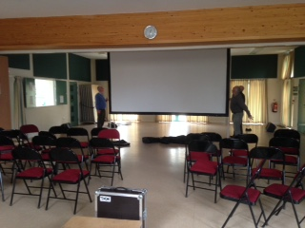

**Ashenground Community Films** – have you attended one of our films yet? We’ve held eight so far and the next one is on **Saturday 25th November** when we will be screening The Time of Their Lives at 7pm. We serve refreshments and we have a licensed bar which is open before the film and during the short interval break. We also hold a small raffle when you could win tickets our next film which will be in January 2018. Details of how to book your tickets can be found on our Website and on our noticeboards.

**The Time of Their Lives** is a feel good British comedy where former Hollywood siren Helen (Joan Collins) finds herself out of work and desperate for one last chance to be in the limelight & prove to Hollywood she’s not an old has-been. Determined to gate-crash her ex-lover’s funeral on a glamorous French hideaway, Helen escapes her London retirement home with the help of Priscilla (Pauline Collins), a repressed housewife stuck in a bad marriage.

Pooling their limited resources, they hit the road for an unforgettable journey by coach, ferry, car and foot in a race to get to the funeral on time, becoming entangled in a love triangle with a reclusive Italian millionaire (Franco Nero).

The **Community Café** project is being worked on by a group of our Trustees. Following successful

funding applications to Gatwick Airport Trust, West Sussex CLC, Haywards Heath Town Council and

Sussex Stragglers who sponsored us, we were granted planning permission for the addition of a

Conservatory to the Back Rooms of the Centre so we can accommodate an affordable afternoon

café. We are still fundraising for the equipment required for this project and hope to be in a

position to launch the café early in the New Year. In the meantime the conservatory is available to

hire as an extra room.

**DETAILS OF PHOTCOPYING FACILITY**

The office at the Centre offers a comprehensive photocopying and printing service. To find out the hours of availability and the schedule of rates, please contact the Centre Manager.

**Remember, this is YOUR Community Centre. We have space for a few more activities and we would like your ideas. The Centre can also be hired for meetings, parties and events, but please be aware that the Main Hall is extremely popular, so the advice is to book early.**

**ACTIVITIES FOR CHILDREN**

**Hedgehogs Nursery** Mon - Fri 9.30 – 12.30 during term time.

Children 2 – 5 years. Contact Selina 457307

**Kangaroos** Saturday 1.30 - 4.30pm during term time, plus holiday schemes

Activities for children & young people with severe learning difficulties. Contact Jenni 459108

**Tiddlers** Wednesday 1.30 - 3pm during term time

Mother and Toddler Group for pre-school children. Contact Jane 453726

**Sing + Sign** Friday 9am -1.30pm during term time

Communicate before baby can speak. Contact Jane janemarshall@singandsign.co.uk

**Franglophones** Weekly Wednesday 9.30 – 12 during term-time

Mother and toddler group for French speaking families. Contact Emilie 211338

**Lucastes Languages** Weekly Saturday 9 – 11.30am during term time

Spanish lessons for children. Contact Rebecca 457147 [becks@lucasteslanguages.uk](mailto:becks@lucasteslanguages.uk)

**Creation Station** Weekly Monday 9 – 12noon during term time

Art and messy play for pre-schoolers. 07789125922 melaniejeffries@thecreationstation.co.uk

**Turning Pointe** Weekly Monday 3 – 7pm and Saturday 9 – 12.30pm during term time

Modern Ballet for Primary aged children. juliacanneaux@hotmail.co.uk

**ACTIVITIES FOR ADULTS**

**Mid-Sussex Bridge Club** Weekly Monday 7.15 – 11pm

All welcome. Contact Suzanne 451796

**Folkdance Club** First & third Tuesday of the month 8 – 10pm

All welcome. Contact Mike 482741

**Horizon** Second Tuesday of the month 8 – 9.30pm

Women’s Group with speakers and craft activities. Contact Barbara 440805

**Pilates** Weekly Monday 6.45 - 9pm and Wednesday 6 – 8.15pm

Pilates for beginners upwards. Contact Darryl 01825 731839

**Parkinson’s UK** Weekly Tuesday 1.30 - 5pm

Exercise class for people with Parkinson’s. Contact Sue 483504

Also Conversation skills First Wednesday of the month 2 – 5pm

**Phoenix Club** Weekly Monday 4 – 6.30pm

A drop-in club for adults with mental health problems. Contact Gordon 417099

**ACTIVITIES FOR ADULTS continued**

**Sama Karate** Weekly Tuesday 6.45 – 7.45pm & Thursday 7 – 8pm

Kickboxing classes. Contact Ben 07929 056674

**Table Tennis** Weekly Thursday 8 – 10pm

All welcome, equipment provided. Contact Debbie 410361

**Yoga** Weekly Monday and Wednesday 7 – 8.30pm

Relax and tone your body with Yoga. Contact Bill 441659

**Give us a Break** Third Thursday of the month 10am – 12.30pm

Daytime support group with activities for carer’s. Contact Gordon 01273 831799

**Carer’s Support** Monthly Second (6.30 – 8.30pm) & last Tuesday (7 – 8.30pm)

Group for carer’s of people with Mental Health Issues – Second Tuesday

Group for carer’s of people with Eating Disorders – last Tuesday

Contact 01293 657043 [info@carerssupport.org.uk](mailto:info@carerssupport.org.uk)

**Whyweight** Weekly Thursday 5.30 – 7pm

Bariatric exercise class. Contact [www.4healthyweight.com](http://www.4healthyweight.com)

**Rebecca**  Weekly Wednesday 7.30 – 8.30pm

Adult Jazz dance group. Contact Rebecca 454369

**Pilates** Weekly Friday 7.15 – 8.15pm term time

Pilates for all. Contact Jacquie 483726

**Up & Amble** 2nd and 4th Thursday of the month 10 – 12noon

Level 1 walk in Ashenground Woods followed by coffee. Contact Tina 455760

**Back & Body Reconditioning**  Weekly Tuesday 5.30 – 6.30pm

For people with Osteoporosis by a specialist physiotherapist. Contact Bex 07970505186

**WI Art** Weekly Tuesday 10.30 – 12.30 during term-time

WI Art workshop. Contact [janWwhite@btinternet.com](mailto:janWwhite@btinternet.com)

# **ACTIVITIES FOR RETIRED PEOPLE**

**Lunch Club** Second Monday in the month 12.30 – 2pm

A simple lunch of soup or ploughman’s Contact Ursula 451861

**Tuesday Club** Weekly Tuesday 2 – 4pm

Social group with board games. Contact Kathy 483294

Where to find us…

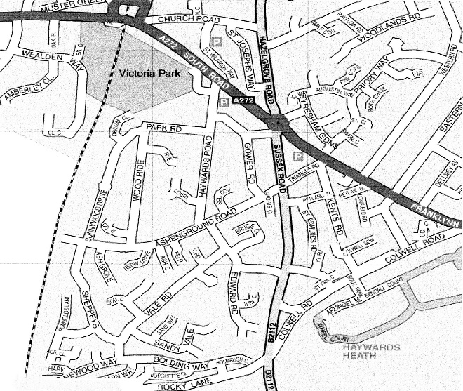

**ACC**

**Useful Numbers**

Ascension Church – Rev. Sarah Upchurch 07910 464404 - www.ascensionchurch.co.uk

Non-emergency Police – 101 Crimestoppers 0800 555111

MSDC Help point – 458166 - [helppoint@midsussex.gov.uk](mailto:helppoint@midsussex.gov.uk)

Citizens Advice Bureau 08444 771171 - [www.adviceguide.org.uk](http://www.adviceguide.org.uk)

Youth Matters – 243922 - www.yourspacewestsussex.co.uk

Town Councilors – Anne Boutrup 07912 112484 anne.boutrup@haywardsheath.gov.uk

Sujan Wickremaratchi 07968 179083 [sujan@haywardsheath.gov.uk](mailto:sujan@haywardsheath.gov.uk)

Howard Mundin 07802 603446 [howard.mundin@haywardsheath.gov.uk](mailto:howard.mundin@haywardsheath.gov.uk)

District Councilors – Anne Boutrup 07912 112484 [anne.boutrup@midsussex.gov.uk](mailto:anne.boutrup@midsussex.gov.uk)

Howard Mundin 01444 414707 [howard.mundin@midsussex.gov.uk](mailto:howard.mundin@midsussex.gov.uk)

County Councilor – Sujan Wickremaratchi 078968 179083

[sujan.wickremaratchi@westsussex.gov.uk](mailto:sujan.wickremaratchi@westsussex.gov.uk)

The Centre’s Management Committee and Board of Trustees is seeking further members from the community. If you can attend an evening meeting approx. every 5-6 weeks, then please contact Sue, via the details below, to find out more.

**CONTACT DETAILS:**

**Centre Manager: Sue Neatherway 01444 447050**

**E-mail:** [**AshengroundCC@talktalk.net**](mailto:AshengroundCC@talktalk.net)

**Website:** [**www.ashengroundcc.org**](http://www.ashengroundcc.org)

**Facebook: Ashenground Community Centre**